**Project management**

Decisions made

13/2/2020

The first major decision we all had to make was what project we wanted to make. After much group discussion we decided that car detection was the best choice and something we were all interested in.

Next, we had to decide which missions everyone wanted to do. I picked up project management and additional data as no one else spoke up about it. Mark chose project ideation and Baseline implementation. Kenneth took project testing and solution review. With Pablo not being in contact we sent a message and waited on his response.

19/2/2020

We have a new member, Owen. Owen was available and chose his missions as GUI and API

Schedule:

24/2/2020

For making this schedule I will be using Mondays to keep track of events.

For the initial draft I decided that everyone should research a topic that would help us create this system. For example methods of how bounding boxes are found, and other algorithms involved in machine vision.

After this there will be a steady work flow of taking a week to develop the algorithm to work via detection in images. Then we will move onto video which will be allowed 2 weeks of development, before starting on the side missions. Shortly after these are created we will change the algorithm to support multiple different types of vehicle, not just cars.

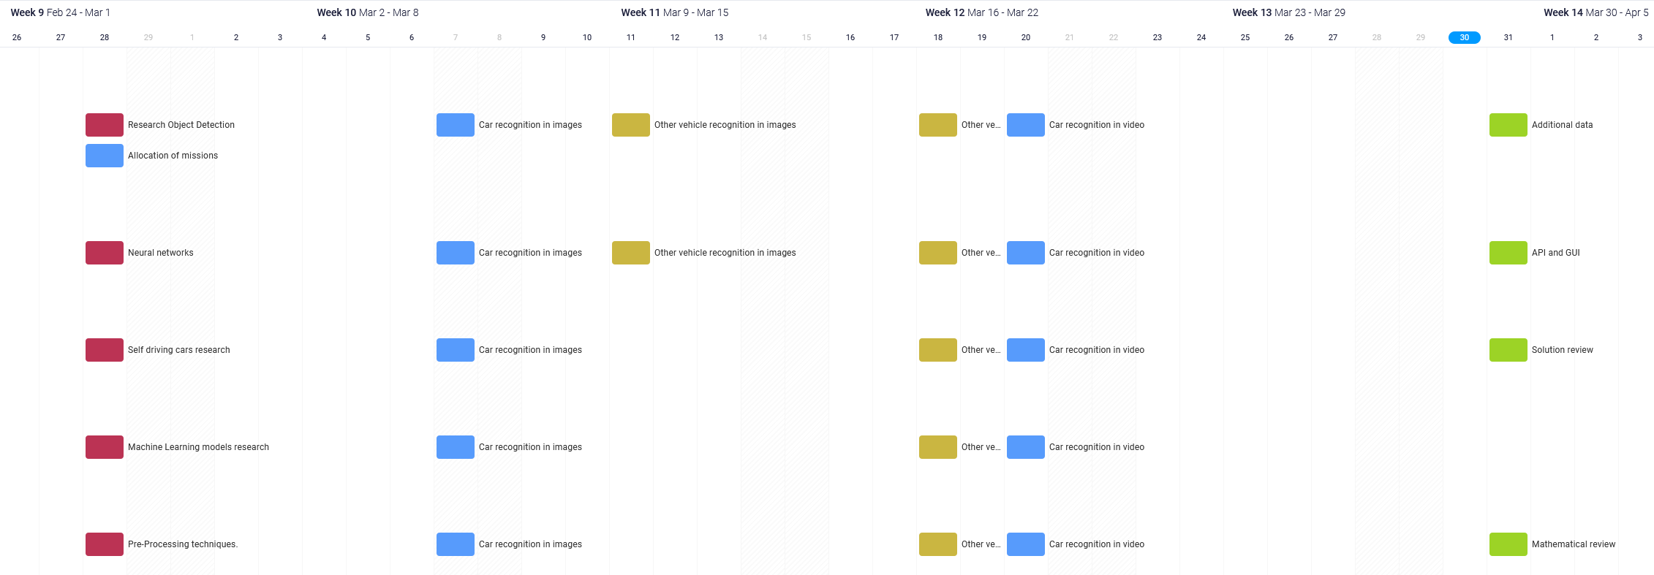

30/3/2020

Due to multiple unforeseen issues which have destabilised this workflow I have had to make several adjustments to compensate.

The first issue has been that it has taken several weeks for the initial algorithm to be developed, after now being moved up to urgent priority it has now been created on the 25/3/2020. Missing most deadlines, therefore I have been forced to push back all deadlines to compensate for this.

The second issue has been that COVID-19 has made real time tracking of cars now impossible due to the lockdown, I will therefore be removing this from the scheduled list of things to do.

Other smaller changes I have made have been pushing testing deadlines to the end of the assignment deadline. As I believed it to be unfair to give Kenneth only 2 days to test this algorithm.

As well as this I have moved the other vehicle recognition to be 2 separate weeks after video recognition has been implemented.

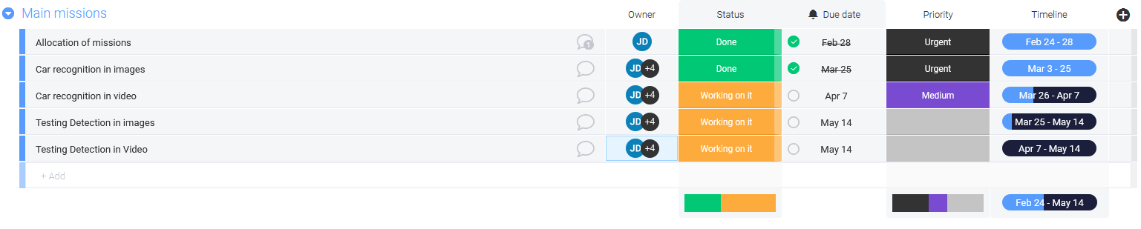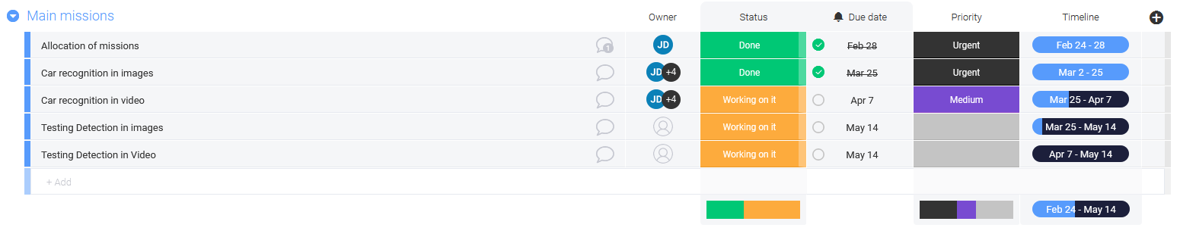

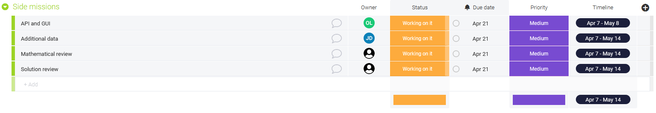

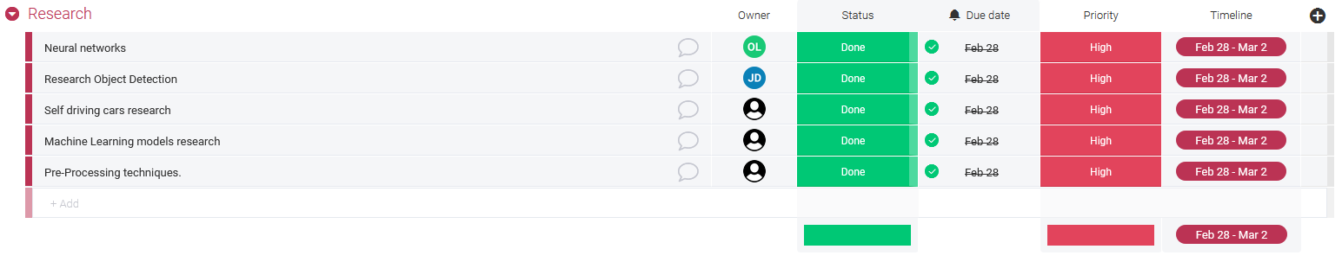

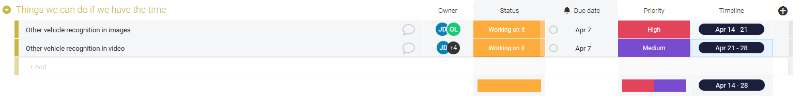

28/4/2020

As of today I have no idea how close anyone is to completing their assigned tasks, no one has attended meetings in 3 weeks apart from Kenneth who simply said he is getting on fine with his work. In the next week I will be chasing people for their work so that I can eventually upload it before the hand in date. I have provided folders for those who are able to contribute to upload their work should they finish it and not with to send me it. With the exception of Kenneth who has been struggling getting connected to the github repository due to his email not being accepted for some reason.

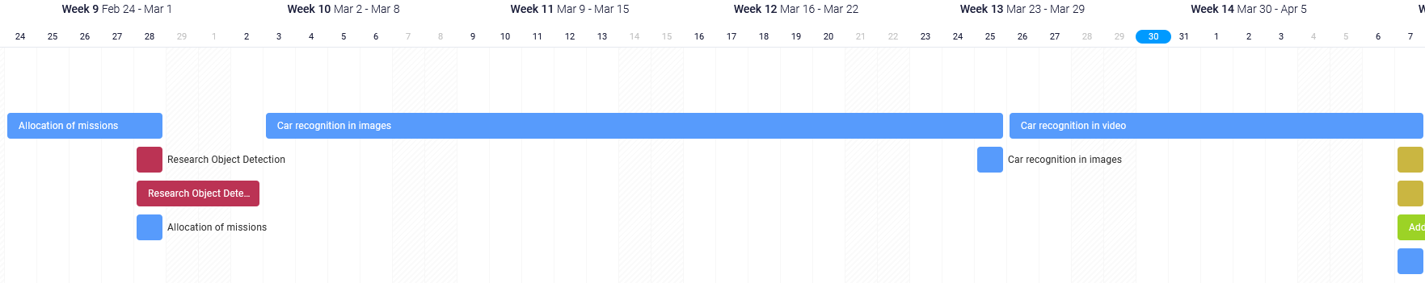

--------------------------------------------------------------------------------------------------------------------------------------

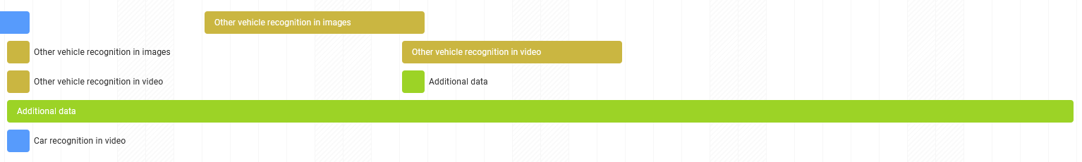

Anomalous events

19/2/2020

We have a 5th member in our team, Owen. With Pablo having not been around to choose his missions it is now between both Pablo and Owen to see who gets what first. They have the choice of Solution design, Mathematical review, API and the GUI.

13/3/2020

University is starting to close its doors due to the coronavirus; this was not anticipated however we always have discord for keeping in contact and GitHub for sharing code with each other. Therefore it shouldn’t affect us too much.

26/3/2020

I have been informed that some of my group members have moved back home due to COVID-19. And thus have limited access to hardware. I referred back to the risk analysis sheet I have created and thus referred them back to google colab, I also offered that I would compute anything such as models when needed as I will not be staying and my hardware is able to do this within a reasonable time frame.